TITLE: AI FIT-TRACK API
PROJECT PHASES

Team Leader:
- TAMILARASAN U & MailID: tamilarasanselvi18@gmail.com
Team Members:
- THIVAKAR S & MailID: thivaselvam7@gmail.com
- THIRUPATHI K & MailID: kthirupathikthirupathi68@gmail.com
- VIGNESH J & MailID: v69905013@gmail.com
PHASE 3
PROJECT DESIGN

1. Architecture.png:

Overall Architecture Components:
- Client Application (React / Mobile App / Postman).
- Express Server.
- API Routes.
- Authentication Middleware.
- Controllers.
- Services.
- Google Gemini AI Service.
- MongoDB Database.
- Mongoose Models.

2. UserFlow.png:

Overall Architecture Components:
- User Registration & Account Setup Flow.
- Authentication & Authorization Lifecycle Flow.
- Workout Management (CRUD & Search) Flow.
- Gemini AI Workout Recommendation Flow.
- Gemini AI Fitness Insights Flow.

3. UserCase.png:
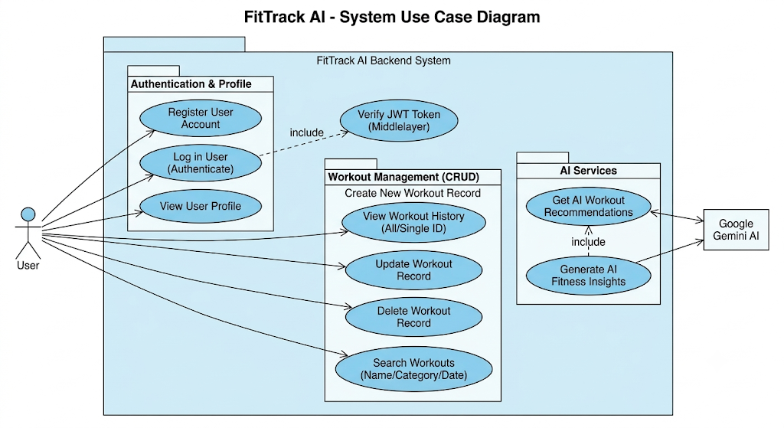
Overall UserCase Components:
- Actors: User (Human Actor), Google Gemini AI (External System Actor).
- Authentication & Profile: Register User, Login User, View User.
- Workout Management (CRUD): Create, Read, Update, Delete.
- AI Services: Get AI Workout Recommendations, Generate AI Fitness Insights.
- Middleware Layer: Verify JWT Token (Middle Layer).

4. DataBase Design.png:
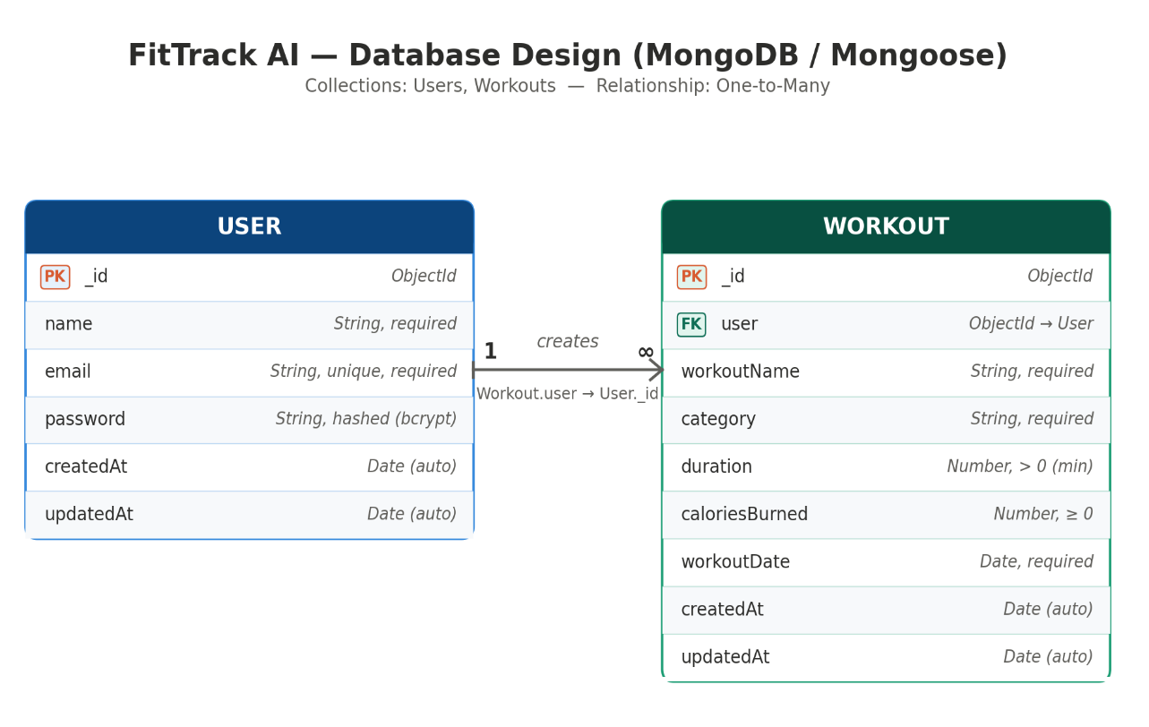
Overall DataBase Components:
- Database: MongoDB (NoSQL, document-based).
- ODM: Mongoose.
- User Entity Fields: _Id, Name, Email, Password, CreatedAt, UpdatedAt.
- Workout Entity Fields: _Id, User, WorkoutName, Category, Duration, CaloriesBurned, WorkOutDate, CreatedAt, UpdatedAt.
- Relationship: One-to-Many.
- Indexs: User.Email, Workout. User, WorkOutName, Category, WorkOutDate.

